7COM1079-0901-2025 - Team Research and Development Project

Final report title: Correlation between mileage and price for used Ford cars (UK market data)

Group ID: A179

Dataset number: DS 179

Prepared by: Prasanth Nandharapu - 24077382
Zakir Mohammad - 24004714
Vamshi Krishna Thanneeru - 24071911
Praveen Kumar Gowridevi - 24085035
Vijay Kumar Kantamaneni - 24072033

University of Hertfordshire
Hatfield, 2025

Table of Contents

- Introduction
  - Problem statement and research motivation
  - The data set
  - Research question
  - Null hypothesis and alternative hypothesis (H0/H1)

- Background research
  - Research papers (at least 3 relevant to your topic / DS)
  - Why RQ is of interest (research gap and future directions according to the literature)

- Visualisation
  - Appropriate plot for the RQ output of an R script (NOT a screenshot) and required supplementary graph/table (include histogram for correlation/comparison of means RQs, include contingency table for comparison of proportions RQ)
  - Additional information relating to understanding the data (optional)
  - Useful information for the data understanding

- Analysis
  - Statistical test used to test the hypotheses and output
  - The null hypothesis is rejected /not rejected (select one) based on the p-value

- Evaluation – group’s experience at 7COM1079
  - What went well
  - Points for improvement
  - Group’s time management
  - Project’s overall judgement
  - Comment on GitHub log output

- Conclusions
  - Results explained.
  - Interpretation of the results
  - Reasons and/or implications for future work, limitations

- Reference list
Harvard (author, date) format.
- Appendices
- R code used for analysis and visualisation.
- GitHub log output.

1. Introduction

  - Problem statement and research motivation (100 words)
Used car pricing is known to be a complex task that comes under the influence of several car factors however, car mileage is known to be one of the primary factors influencing such car pricing. To accurately calculate the impact of car mileage on pricing and ensure that optimized decisions can be made by car buyers and sellers as well as pricing algorithms (car pricing engines), research is required (Engers, 2009). The research project above utilizes a substantial number of UK car models from Ford and aims to determine the impact and intensity of car mileage on car pricing.

  - The data set (75 words)
The file ford.csv holds 17,965 cars observations in UK market sold under the Ford brand. The important columns include model, year, Price , transmission, Mileage and mpg. The cleaning process for this file included converting Price and Mileage to number and removing observations with missing values . This resulted in n = 17,965 complete cases for the bivariate analysis. Price and Mileage can be taken as interval/ratio variables as they can be calculated and compared.

  - Research question (50 words).
RQ: Is there a correlation between mileage (miles) and price (GBP) for used Ford cars within the given dataset?
Dependent variable: Price (GBP). Independent variable: Mileage (miles). It is a correlation (continuous vs continuous) RQ – suitable for Pearson correlation (linear association) and Spearman correlation (monotonic association).

  - Null hypothesis and alternative hypothesis (H0/H1) (100 words)
H0 (null): On the given dataset, there is no linear relationship between mileage and pricing for the population (Pearson r = 0).
H1 (alternative): A linear correlation exists between Mileage and Price (Pearson r ≠ 0).
As both the variables are skewed, for robustness analysis purposes, the non-parametric method (Spearman's rho correlation) is computed. α is set at 0.05. If p <0.05, then H0 is rejected and it is inferred that the result is statistically significant

- Background research

- Research papers (at least 3 relevant to your topic / DS) (200 words)
- Engers, M. (2009). The effect of mileage on used car prices. In this study, Engers examined the impact of both age and mileage on resale prices and showed that higher mileage is associated with a reduced resale price. This is sufficient reason to examine the impact of mileage on specific car models.

- Žiačik, J. (2023). Determinants of Used Car Prices. Žiačik uses regression analysis and machine learning and finds that mileage is one of the strongest negative predictors for car prices regardless of model and brand: Depreciation rates depend on mileage classes.

- Bergmann, S., et al. (2024). Machine learning for predicting used car resale prices. A comparison between linear models and ensemble methods shows thatmileage and car age feature prominently and that interaction terms and nonlinear transformations should be included for optimal model behavior.
These studies verify the emphasis on mileage as a predictor and imply that research on nonlinear models and multivariate hedonic regressions adjusting for various factors (car model and year of production and engine capacity) is warranted.

  - Why RQ is of interest (research gap and future directions according to the literature) (100 words)

It is known from current literature that mileage is significant and usually studied on a global scale; the specific brand/model behavior is understood to be less analyzed. The current RQ on a considerable brand-focused (Ford) sample from UK provides an empirical point of reference. It is important for the next research to generate multivariable hedonic regressions and model nonlinear and mileage band effects with various models for predicting the influence on prices after conditioning on mileage.

- Visualisation

  - Appropriate graphs for the RQ) (50 words)
Main plot: scatterplot of mileage (x-axis) vs price (y-axis) with an OLS regression line and 95% confidence band (produced by script). Supplementary plots: histogram of price and histogram of mileage, each with a normal density overlay to inspect distributional shape. These visuals support test selection and show relationship direction.

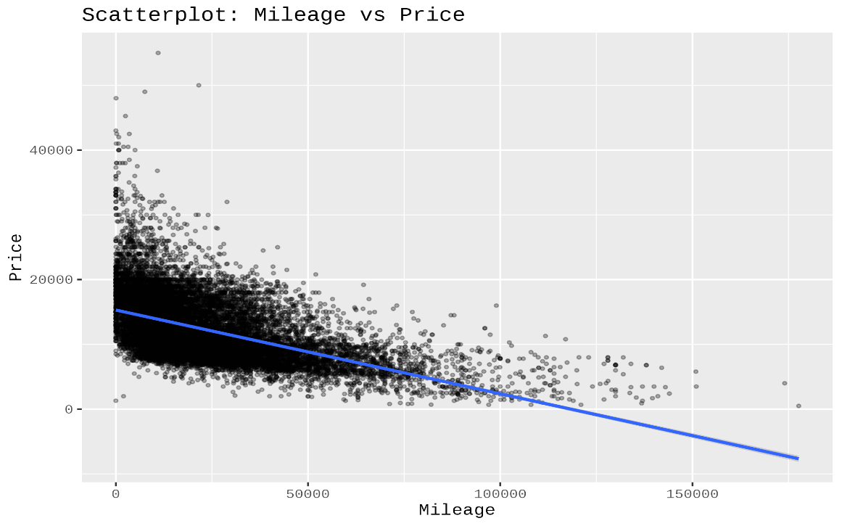

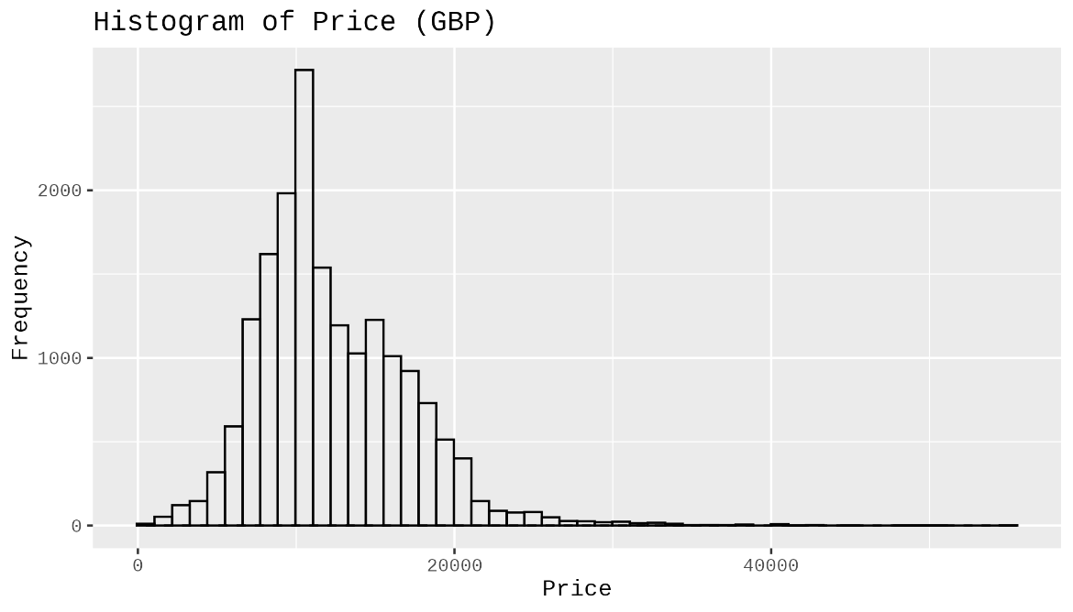
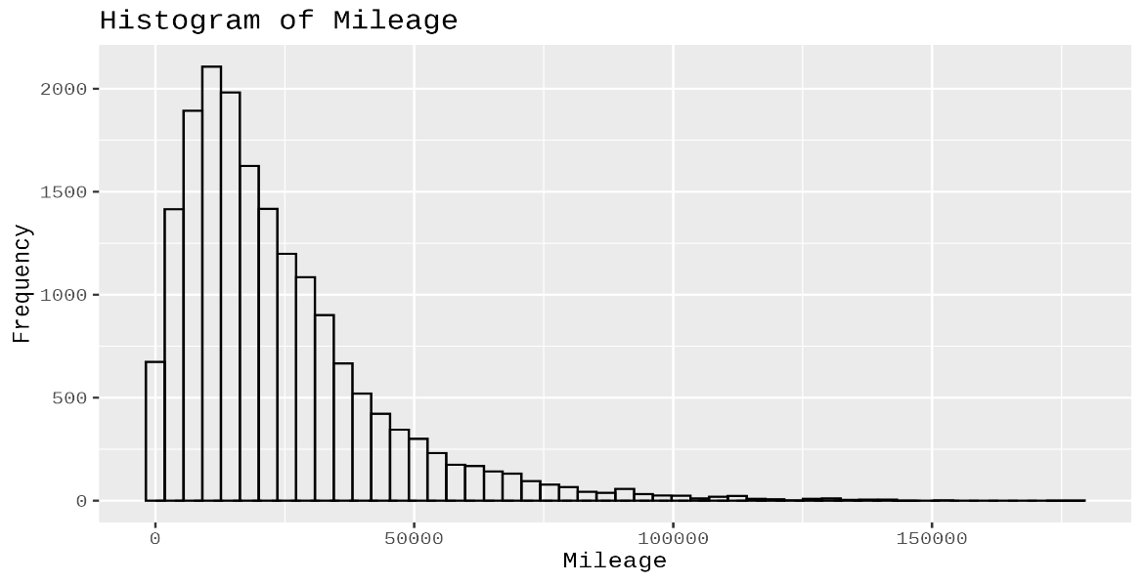

  - Additional information relating to understanding the data (optional) (50 words)
Histograms: Both for prices and for mileages, there is evidence of right-skewing (right tails). From the scatter diagram, there is evidence that the scatter is linear with considerable variation along the y-axis, and thus mileages are important and multiple other factors explain variation for residual observations.

  - Useful information for the data understanding (50 words)
Main observations: sample size n = 17,965. Price and mileages vary considerably; prices tend to cluster around lower values with a rightward tail, mileages tend to be non-normal with numerous low to moderate and a number with high mileages. Scatter diagram depicts a negative correlation with heteroscedasticity

- Analysis

  - Statistical test used to test the hypotheses and output (75 words)
Initial test: Pearson’s correlation to establish the presence/absence of linear relationship between two continuous variables. Given the two skewed variables, a Spearman’s rank test was performed to confirm the robustness of the monotonic relationship. Fitted a basic OLS model: price ~ mileage to provide the marginal and R² values. Pearson’s r = -0.530727 (p < 0.001), Spearman’s rho = -0.57665 (p < 0.001) OLS slope = -0.1292 (decreases ~ £0.129 per mile) R² = 0.282

  - The null hypothesis is rejected /not rejected based on the p-value (100 words)
Decision: Reject H0. The Pearson and Spearman tests both reported p-values is zero (p < 0.001), and we reject the null hypothesis of no relationship at significance level α = 0.05. Conclusion :- There is a statistically significant negative relationship. The size of the Spearman rho is slightly larger than that of Pearson r, reflecting that the former monotonic relationship is a marginally stronger relationship than the linear relationship due to skew and other factors. The OLS model accounts 28.2% of the variation in price (R-squared = 0.282), and mileage is an important but not sole factor in the regression)

Evaluation – group’s experience at 7COM1079

  - What went well (75 words)
We worked with a large and plausible dataset, performed data cleaning and exploratory data analysis, chose an effective RQ, and made our code and plots reproducible. Our statistical methods (Pearson, Spearman, OLS) were data-suited and yielded the expected results. The breakdown in our tasks (data cleaning, analysis, writing) was effective and helped in meeting the deadlines.

  - Points for improvement (75 words)
We should have applied earlier the multivariate analyses to control for confounders, applied transformations (such as log price to correct for skew), and checked in more frequently to maintain code style and merging rules. Versioned notebooks and unit testing of the R code would enhance reproducibility and minimize last-minute hacking

  - Group’s time management (50 words)
Time breakdown: data cleaning and exploratory data analysis (30%), statistical testing and graphics (40%), report writing and proofreading (25%), final packaging (5%). We met our schedule but cut proofreading towards the end—we should give more time to proofreading for a better final product.

  - Project’s overall judgement (50 words)
Objectives were satisfied: RQs were clear and well-articulated, bivariate analyses were strong, and scripts allowed replicability. The size of the dataset facilitated powerful statistics and resulted in results that matched the literature. The investigation could be applied to predictive and valuation models if extended to multivariate analyses
  - Note any changes to group since original allocation if applicable. Add new or amended GitHub Ids for new members (75 words, write only if applies to your group arrangements)
No membership changes occurred during the project.

  - Comment on the GitHub log output (50 words)

- Commit Message: “Refactor analysis script to pure base R and enable full multi-plot output”
This commit greatly enhanced the technical viability of the project as it eliminated package dependencies and coded all analysis procedures in base R. It made it more portable and ensured that there were no compatibility problems. Moreover, it ensured that graphics were generated uniformly. The multi-plot feature made analysis more transparent.

- Commit Message: “Dataset-Visualisation-Outputs”
This commit offered significant progress with the inclusion of all processed datasets and graphics necessary for the completion of the statistical analysis. The graphics facilitated easy analysis of trends, distribution, and possible anomalies, which aided significantly in making decisions on subsequent stages. The graphics served as the fundamental basis for all findings contained within the report.

- Commit Message: “project-presentations”
The impact of this commit involved the inclusion of the presentations that communicated the project methodology, analysis, and findings. It rendered complex statistical procedures accessible via presentations useful for project assessment. The impact of this commit widened project influence as it ensured project findings were communicated effectively, thus enhancing project academic and professional deliverables.

Conclusions

  - Results explained (75 words)
The results indicate a moderate to strong negative relationship between mileage and price for the second-hand Fords available in the sample.
Pearson’s r = -0.531 and Spearman rho = -0.577 (in both cases, P > |z| = 0.0001), indicating higher mileage is associated with lower asking prices. OLS regression reveals a correspondingly marginal negative relationship a fall of approximately 0.129 per unit increase in mileage, where mileage explains ~28.2% of the variation in price

  - Interpretation of the results (75 words)
Each additional mile translates into a larger discount, with each additional 10,000 miles worth approximately a £1,292 discount on the OLS value of the slope (10,000 × £0.129). The moderate R² value indicates that mileage is a very important predictor, but other variables such as the age, model and condition of the vehicle need to be accounted for proper assessments. The stronger correlation in the Spearman rho indicates non-linear relationships relating to the mileage predictor

  - Reasons and/or implications for future work, limitations of your study (50 words)
Limitations: bivariate analysis has uncontrolled confounders and potentially OVB issues, and observations are based on listed prices, not sale prices. Future studies should employ hedonic regression with controls or machine learning models and test for nonlinear miles terms/bins and respective depreciation curves and markets

- Reference list (not included in the word count)

Academic sources
Andy Field (2018)
Field, A. (2018) Discovering Statistics Using IBM SPSS Statistics. 5th edn. London: SAGE Publications.
Andy Field, Miles & Field (2012)
Field, A., Miles, J. and Field, Z. (2012) Discovering Statistics Using R. London: SAGE Publications.
Moore, Notz & Fligner (2018)
Moore, D.S., Notz, W.I. and Fligner, M.A. (2018) The Basic Practice of Statistics. 8th edn. New York: W. H. Freeman.
Frost (2019) – Statistics by Jim
Frost, J. (2019) Regression Analysis: An Intuitive Guide. Statistics by Jim Publishing.
Berenson, Levine & Szabat (2018)
Berenson, M.L., Levine, D.M. and Szabat, K.A. (2018) Basic Business Statistics: Concepts and Applications. 14th edn. Harlow: Pearson.
Hosmer, Lemeshow & Sturdivant (2013)
Hosmer, D.W., Lemeshow, S. and Sturdivant, R.X. (2013) Applied Logistic Regression. 3rd edn. Hoboken: Wiley.

Correlation & regression theory
Cohen, Cohen, West & Aiken (2013)
Cohen, J., Cohen, P., West, S.G. and Aiken, L.S. (2013) Applied Multiple Regression/Correlation Analysis for the Behavioral Sciences. 3rd edn. New York: Routledge.
Dancey & Reidy (2017)
Dancey, C.P. and Reidy, J. (2017) Statistics Without Maths for Psychology. 7th edn. Harlow: Pearson.
Miles & Banyard (2007)
Miles, J. and Banyard, P. (2007) Understanding and Using Statistics in Psychology. London: SAGE Publications.

Normality, histograms, and data screening
Tabachnick & Fidell (2013)
Tabachnick, B.G. and Fidell, L.S. (2013) Using Multivariate Statistics. 6th edn. Boston: Pearson.
Osborne (2010)
Osborne, J.W. (2010) Improving your data transformations: Applying the Box-Cox transformation. Practical Assessment, Research, and Evaluation, 15(12), pp. 1–9.

Spearman & Pearson correlation references
Spearman (1904)
Spearman, C. (1904) ‘The proof and measurement of association between two things’, American Journal of Psychology, 15(1), pp. 72–101.
Pearson (1896)
Pearson, K. (1896) ‘Mathematical contributions to the theory of evolution III. Regression, heredity and panmixia’, Philosophical Transactions of the Royal Society of London, 187, pp. 253–318.

Dataset source (Kaggle)
Kaggle (2020) Ford Used Car Dataset. Available at: https://www.kaggle.com

- Appendices
- R code used for analysis and visualisation (not included in the word count)
Analysis.R code with the appropriate statistics to test the hypotheses.

# ---- READ CSV ----
df <- read.csv("ford.csv", stringsAsFactors = FALSE)

# ---- CLEAN / CONVERT ----
df$price <- as.numeric(df$price)
df$mileage <- as.numeric(df$mileage)

# Remove NA rows
df_clean <- df[!is.na(df$price) & !is.na(df$mileage), ]

# ---- FIRST 5 ROWS ----
cat("FIRST 5 ROWS:\n")
print(head(df_clean, 5))

# ---- SUMMARY ----
cat("\nSUMMARY:\n")
cat("Observations:", nrow(df_clean), "\n")

cat("Price mean:", mean(df_clean$price),
" median:", median(df_clean$price), "\n")

cat("Mileage mean:", mean(df_clean$mileage),
" median:", median(df_clean$mileage), "\n\n")

# ---- HISTOGRAMS ----
# Price histogram
hist(df_clean$price,
breaks = 50,
main = "Histogram of Price (GBP)",
xlab = "Price",
col = "white",
border = "black")

# Add normal curve
price_mean <- mean(df_clean$price)
price_sd <- sd(df_clean$price)
curve(dnorm(x, mean = price_mean, sd = price_sd) *
diff(hist(df_clean$price, plot=FALSE)$breaks[1:2]) *
nrow(df_clean),
add = TRUE, lwd = 2)

# Mileage histogram
hist(df_clean$mileage,
breaks = 50,
main = "Histogram of Mileage",
xlab = "Mileage",
col = "white",
border = "black")

# Add normal curve
mileage_mean <- mean(df_clean$mileage)
mileage_sd <- sd(df_clean$mileage)
curve(dnorm(x, mean = mileage_mean, sd = mileage_sd) *
diff(hist(df_clean$mileage, plot=FALSE)$breaks[1:2]) *
nrow(df_clean),
add = TRUE, lwd = 2)

# ---- SCATTERPLOT + REGRESSION LINE ----
plot(df_clean$mileage, df_clean$price,
main = "Scatterplot: Mileage vs Price",
xlab = "Mileage",
ylab = "Price",
pch = 20, col = "#00000055")

# Linear model
model <- lm(price ~ mileage, data = df_clean)
abline(model, col = "blue", lwd = 2)

# ---- SAVE PLOTS (PNG) ----
png("hist_price_base.png", width = 700, height = 400)
hist(df_clean$price, breaks=50, main="Histogram of Price (GBP)",
xlab="Price", col="white", border="black")
dev.off()

png("hist_mileage_base.png", width = 700, height = 400)
hist(df_clean$mileage, breaks=50, main="Histogram of Mileage",
xlab="Mileage", col="white", border="black")
dev.off()

png("scatter_mileage_price_base.png", width = 700, height = 500)
plot(df_clean$mileage, df_clean$price,
main="Scatterplot: Mileage vs Price",
xlab="Mileage", ylab="Price",
pch=20, col="#00000055")
abline(model, col="blue", lwd=2)
dev.off()

# ---- CORRELATIONS ----
cat("\nPEARSON CORRELATION:\n")
print(cor.test(df_clean$mileage, df_clean$price, method="pearson"))

cat("\nSPEARMAN CORRELATION:\n")
print(cor.test(df_clean$mileage, df_clean$price, method="spearman"))

- GitHub log output.

